Test cases “without gaps”:

1. FCFS:

Input:

|  |  |  |
| --- | --- | --- |
| Name | Arrival Time | Burst Time |
| P1 | 0 | 5 |
| P2 | 1 | 3 |
| P3 | 2 | 8 |
| P4 | 3 | 6 |

Expected output:

|  |  |  |  |  |
| --- | --- | --- | --- | --- |
| P1 | P2 | P3 | P4 |  |
| 0 | 5 | 8 | 16 | 22 |

Expected waiting time: 5.75

Program output:

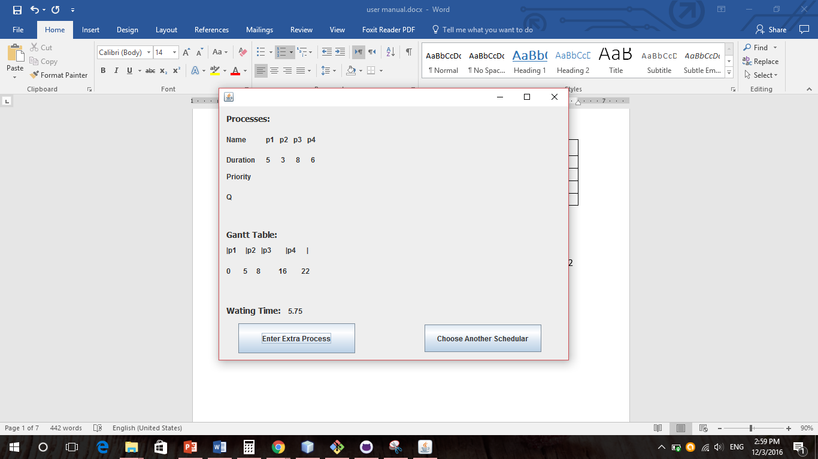

1. Preemptive SJF:

Input:

|  |  |  |
| --- | --- | --- |
| Name | Arrival Time | Burst Time |
| P1 | 0 | 5 |
| P2 | 1 | 3 |
| P3 | 2 | 8 |
| P4 | 3 | 6 |

Expected output:

|  |  |  |  |  |  |
| --- | --- | --- | --- | --- | --- |
| P1 | P2 | P1 | P4 | P3 |  |
| 0 | 1 | 4 | 8 | 14 | 22 |

Expected waiting time: 5

Program output:

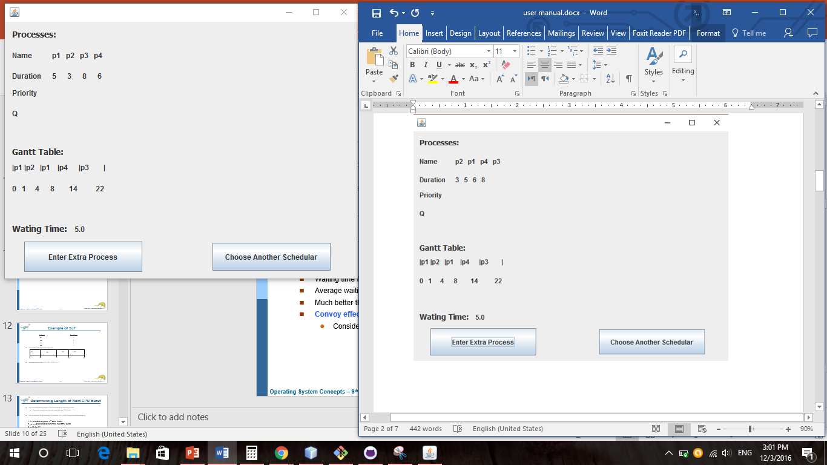

1. Non-preemptive SJF:

Input:

|  |  |  |
| --- | --- | --- |
| Name | Arrival Time | Burst Time |
| P1 | 0 | 5 |
| P2 | 1 | 3 |
| P3 | 2 | 8 |
| P4 | 3 | 6 |

Expected output:

|  |  |  |  |  |
| --- | --- | --- | --- | --- |
| P1 | P2 | P4 | P3 |  |
| 0 | 5 | 8 | 14 | 22 |

Expected waiting time: 5.25

Program output:

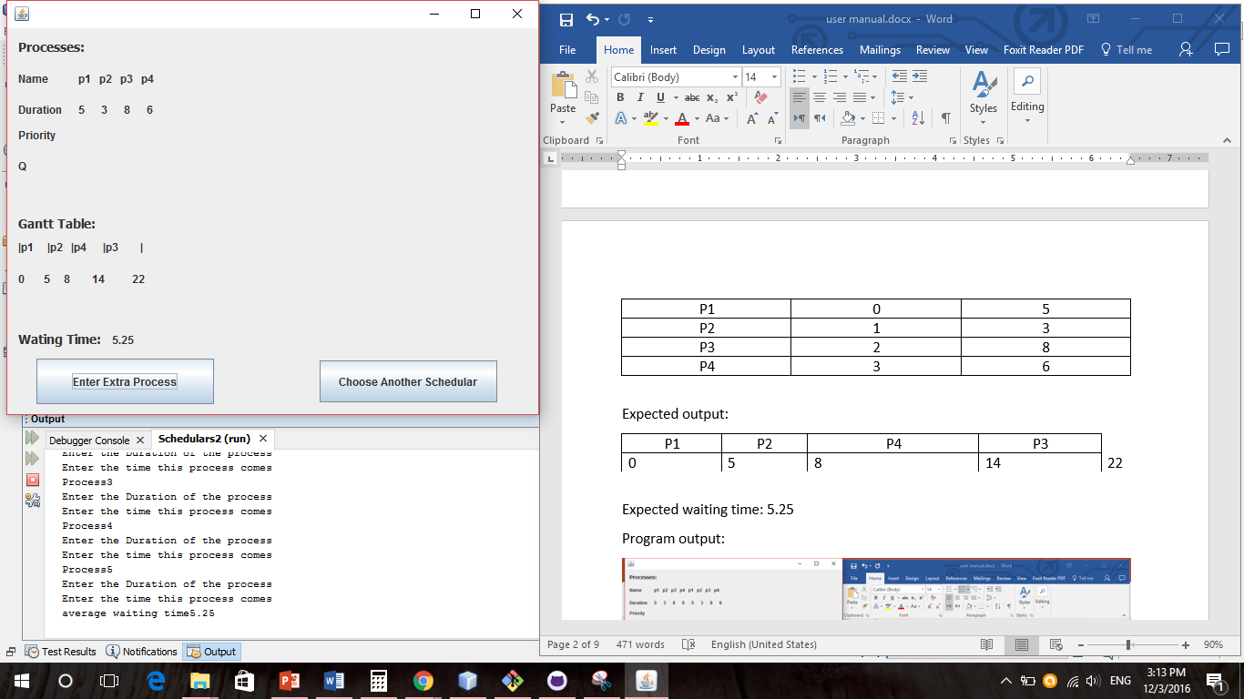

1. Preemptive priority:

Input:

|  |  |  |  |
| --- | --- | --- | --- |
| Name | Arrival Time | Burst Time | Priority |
| P1 | 0 | 5 | 3 |
| P2 | 2 | 6 | 1 |
| P3 | 3 | 3 | 2 |

Expected output:

|  |  |  |  |  |
| --- | --- | --- | --- | --- |
| P1 | P2 | P3 | P1 |  |
| 0 | 2 | 8 | 11 | 14 |

Expected waiting time: 4.66666

Program output:

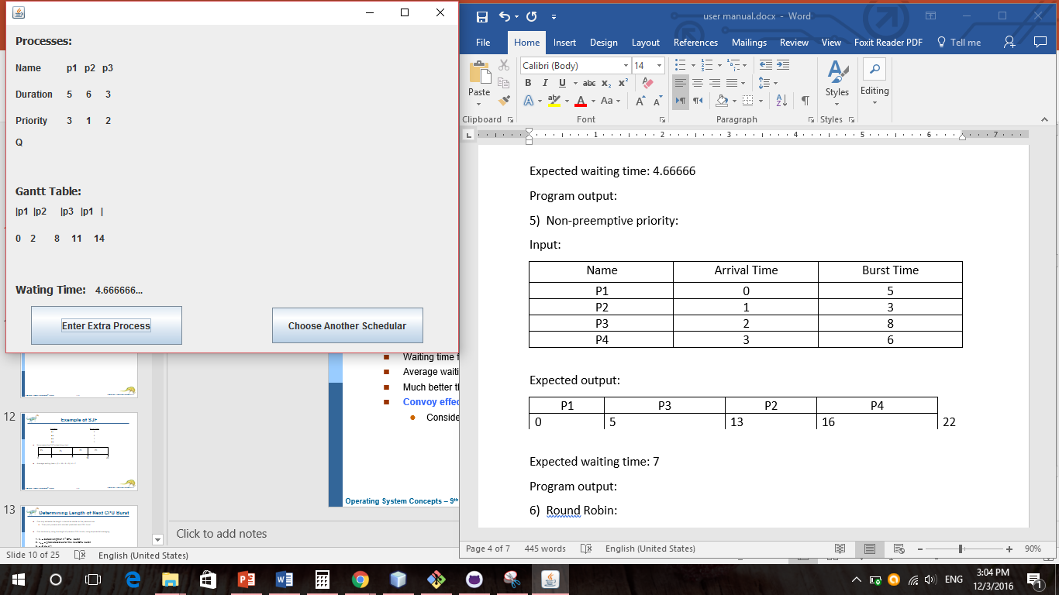

1. Non-preemptive priority:

Input:

|  |  |  |  |
| --- | --- | --- | --- |
| Name | Arrival Time | Burst Time | Priority |
| P1 | 0 | 5 | 1 |
| P2 | 1 | 3 | 2 |
| P3 | 2 | 8 | 1 |
| P4 | 3 | 6 | 3 |

Expected output:

|  |  |  |  |  |
| --- | --- | --- | --- | --- |
| P1 | P3 | P2 | P4 |  |
| 0 | 5 | 13 | 16 | 22 |

Expected waiting time: 7

Program output:

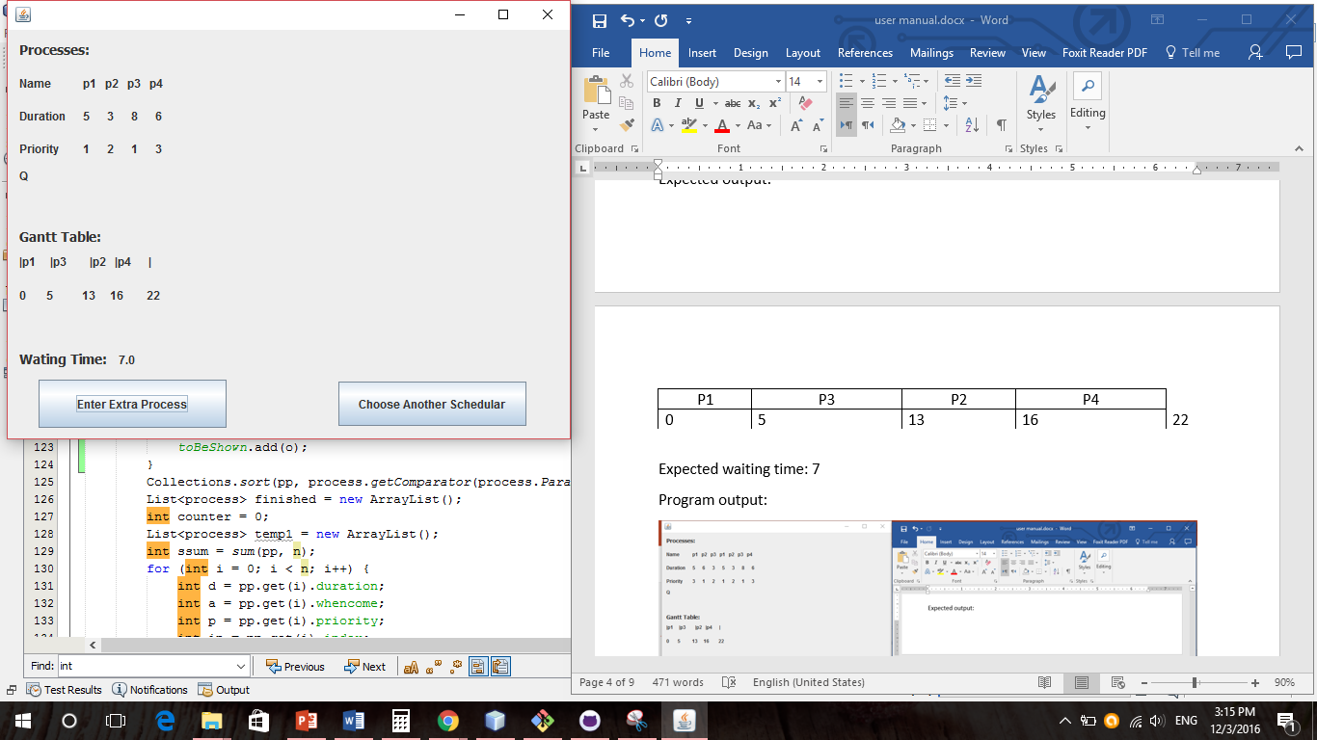

1. Round Robin:

Input:

|  |  |
| --- | --- |
| Name | Burst Time |
| P1 | 5 |
| P2 | 3 |
| P3 | 8 |
| P4 | 6 |

With q=3

Expected output:

|  |  |  |  |  |  |  |  |  |
| --- | --- | --- | --- | --- | --- | --- | --- | --- |
| P1 | P2 | P3 | P4 | P1 | P3 | P4 | P3 |  |
| 0 | 3 | 6 | 9 | 12 | 14 | 17 | 20 | 22 |

Expected waiting time: 10

Program output:

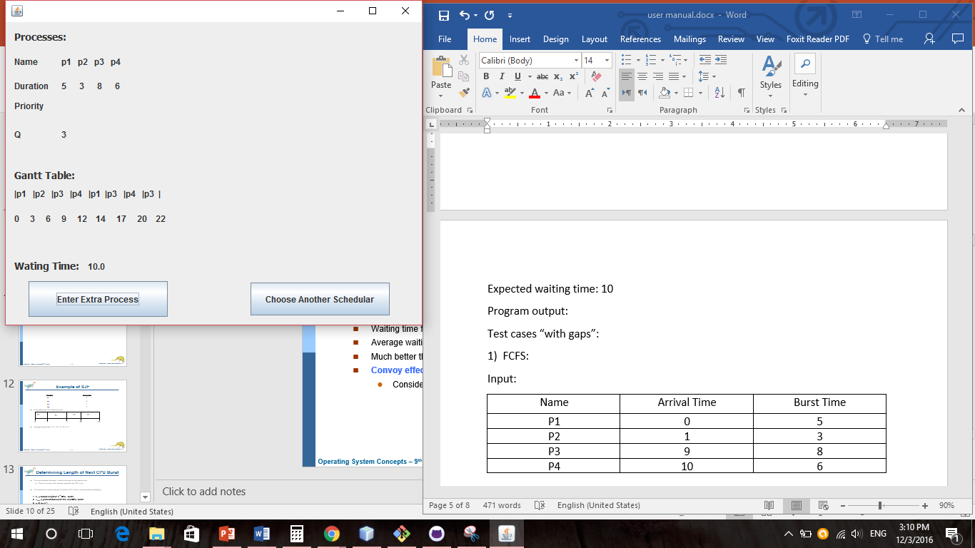

Test cases “with gaps”:

1. FCFS:

Input:

|  |  |  |
| --- | --- | --- |
| Name | Arrival Time | Burst Time |
| P1 | 0 | 5 |
| P2 | 1 | 3 |
| P3 | 9 | 8 |
| P4 | 10 | 6 |

Expected output:

|  |  |  |  |  |  |
| --- | --- | --- | --- | --- | --- |
| P1 | P2 | NOP | P3 | P4 |  |
| 0 | 5 | 8 | 9 | 17 | 23 |

Expected waiting time: 2.75

Program output:

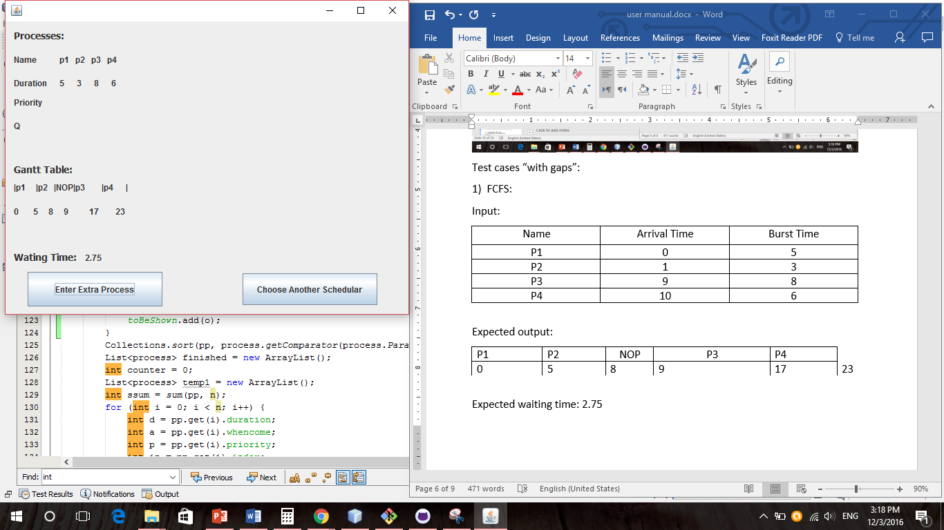

1. Preemptive SJF: //Not working “infinite loop”

Input:

|  |  |  |
| --- | --- | --- |
| Name | Arrival Time | Burst Time |
| P1 | 0 | 5 |
| P2 | 1 | 3 |
| P3 | 9 | 8 |
| P4 | 10 | 6 |

Expected output:

|  |  |  |  |  |  |  |  |
| --- | --- | --- | --- | --- | --- | --- | --- |
| P1 | P2 | P1 | NOP | P3 | P4 | P3 |  |
| 0 | 1 | 4 | 8 | 9 | 10 | 16 | 23 |

Expected waiting time: 2.25

Program output:

1. Non-preemptive SJF:

Input:

|  |  |  |
| --- | --- | --- |
| Name | Arrival Time | Burst Time |
| P1 | 0 | 5 |
| P2 | 1 | 3 |
| P3 | 9 | 8 |
| P4 | 10 | 6 |

Expected output:

|  |  |  |  |  |  |
| --- | --- | --- | --- | --- | --- |
| P1 | P2 | NOP | P3 | P4 |  |
| 0 | 5 | 8 | 9 | 17 | 23 |

Expected waiting time: 2.75

Program output:

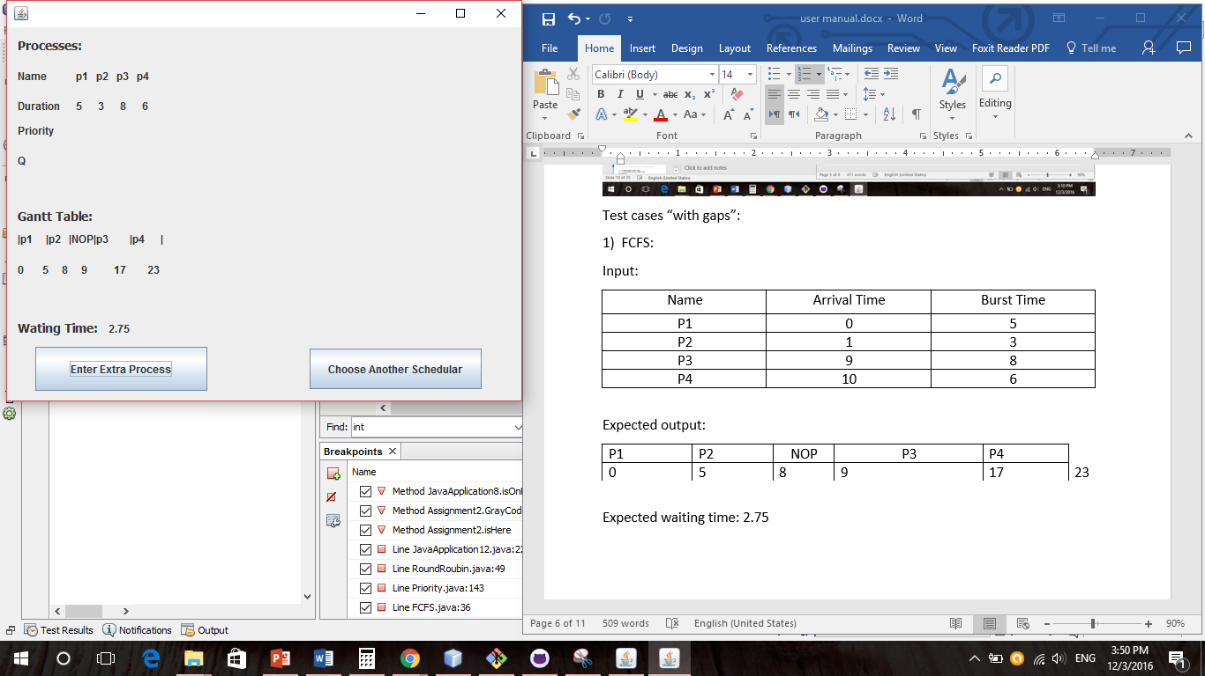

1. Preemptive priority: //infinite loop

Input:

|  |  |  |  |
| --- | --- | --- | --- |
| Name | Arrival Time | Burst Time | Priority |
| P1 | 0 | 5 | 3 |
| P2 | 2 | 6 | 1 |
| P3 | 12 | 3 | 2 |

Expected output:

|  |  |  |  |  |  |
| --- | --- | --- | --- | --- | --- |
| P1 | P2 | P1 | NOP | P3 |  |
| 0 | 2 | 8 | 11 | 12 | 15 |

Expected waiting time: 1.5

Program output:

1. Non-preemptive priority:

Input:

|  |  |  |  |
| --- | --- | --- | --- |
| Name | Arrival Time | Burst Time | Priority |
| P1 | 0 | 5 | 1 |
| P2 | 1 | 3 | 2 |
| P3 | 9 | 8 | 1 |
| P4 | 10 | 6 | 3 |

Expected output:

|  |  |  |  |  |  |
| --- | --- | --- | --- | --- | --- |
| P1 | P2 | NOP | P3 | P4 |  |
| 0 | 5 | 8 | 9 | 17 | 23 |

Expected waiting time: 2.75

Program output:

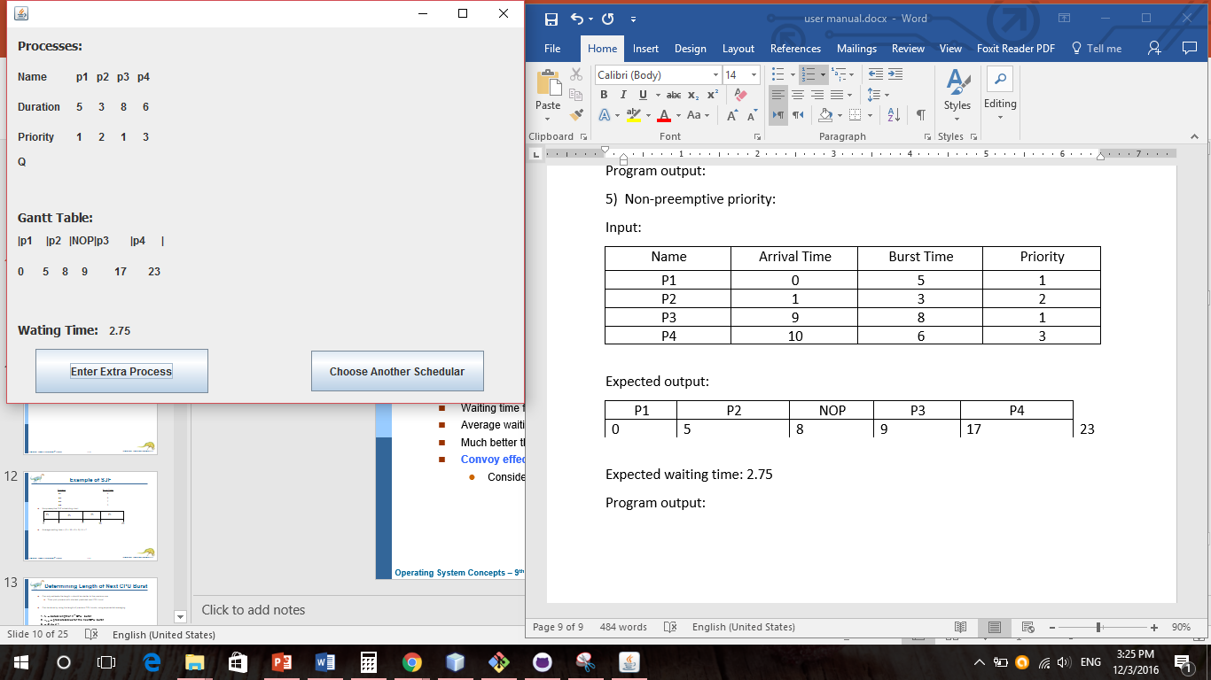

Or as an example we can just start the previous testcases from1 not 0 and then just NOP process will be in the beginning of the Gantt chart and the average witing time will be the same

Example preemptive SJF:

